FOCUS Attendance Notes for Parent Portal
Login to the parent portal homepage:
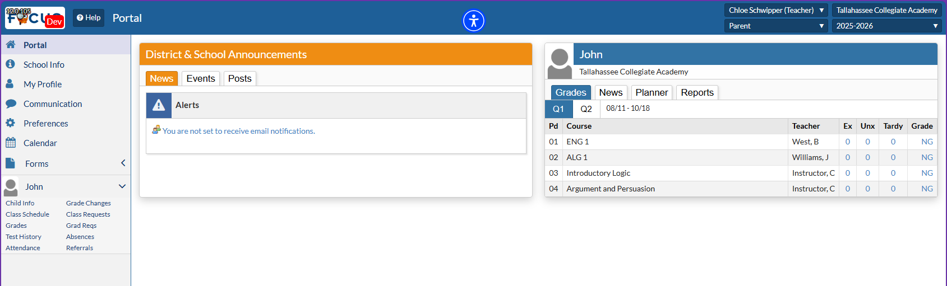
If your student has unexcused absences or tardies, an alert displays on the Portal in the Alerts section. Click the alert to navigate to the Absences (Summary) screen.
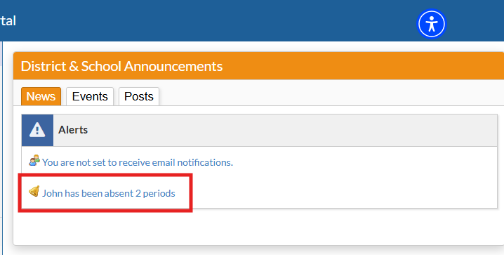
If you do not see an alert about absences, please click on Attendance on the left side menu
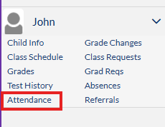
Then, click on Summary
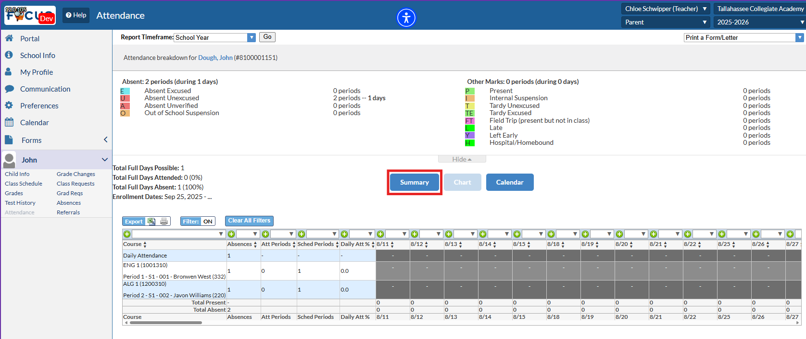
Your screen should change to the Absences Summary Page and look like the image below. If there are no absences listed here, your student was not marked absent for any class period.
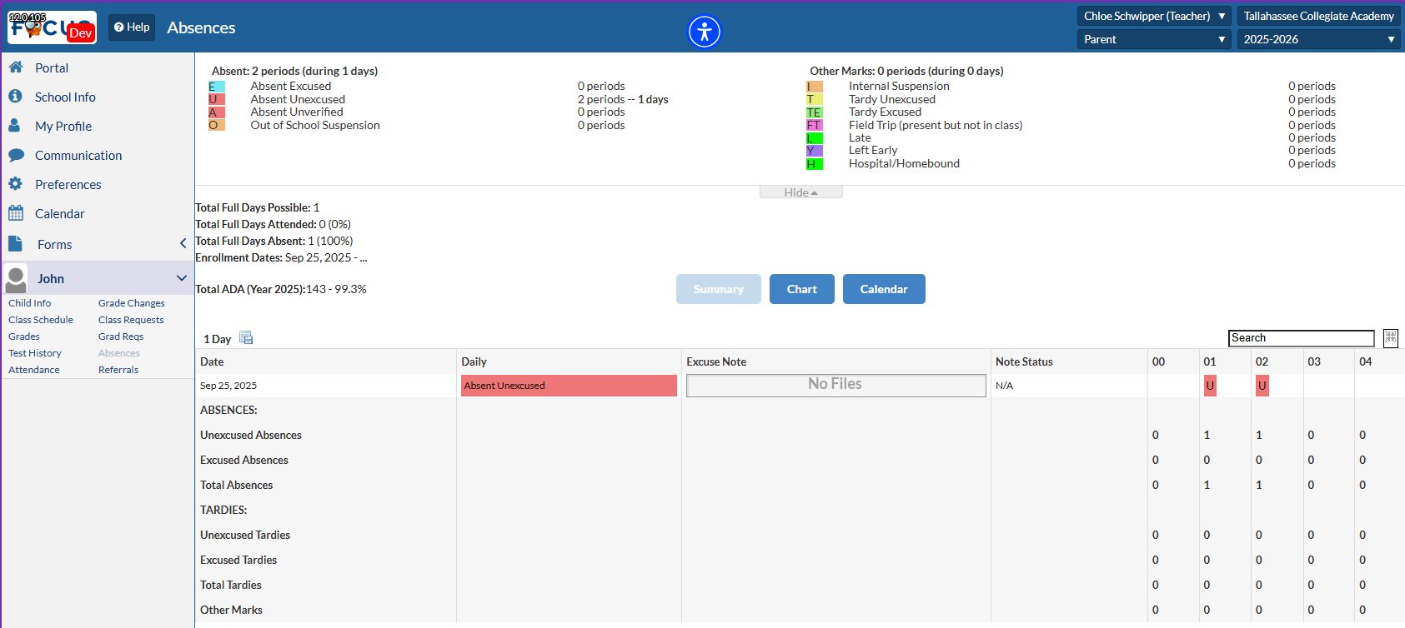

ADDING EXCUSE NOTES:
On the Attendance Summary Screen, hover over the Excuse Note field to get the option to Scan, Upload, or Take Photo.
- Scan – requires a scanner attached to a computer
- Upload – file saved on your device
- Photo – requires a camera on your device
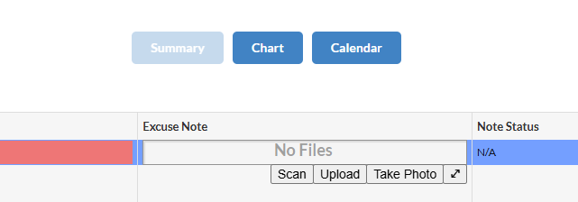

Once an excuse note is uploaded, the field should show the file name that was uploaded.
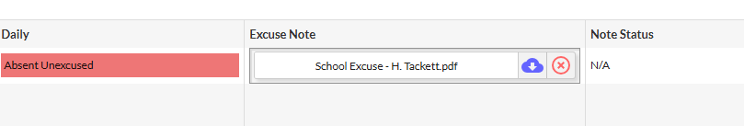
From there, the school will receive a notification that an Excuse Note has been uploaded for Review.
Click on the red X to Delete the excuse note. NOTE: You can only delete excuse notes that you have uploaded. You cannot delete notes uploaded by other users.
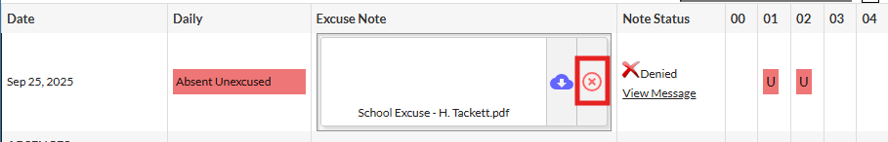
Once the excuse note has been approved by the school, the Note status on the Attendance Summary page will be displayed with a green check mark and Approved.
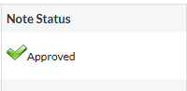
If the Excuse Note was not approved, the following notification will be visible on the parent portal homepage:
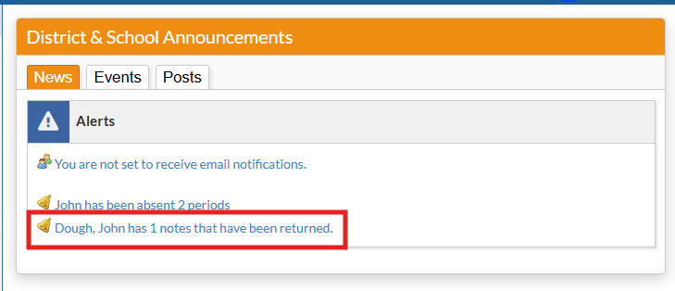
Click on the notification to view the Note Status and read the message for a reason why.
